Customer Shopping Behavior Analysis
By Dr. Ifunanya
- Project Overview
This project analyzes customer shopping behavior using transactional data from 3,900 purchases across various product categories. The goal is to uncover spending patterns, customer segments, product preferences, and subscription behavior to guide strategic business decisions.

- Dataset Summary
- Rows: 3900
- Columns: 18
- Key Features:
  - Customer demographic (Age, Gender, Location, Subscription status)
  - Purchase Details (Item purchased, Category, Purchase Amount, Season, Size, Color)
  - Shopping Behavior (Discount applied, Promo code used, Previous purchases, Frequency of purchases, Review rating, Shipping Type)
- Missing Data: 37 values in Review Rating column

- Exploratory Data Analysis using Python
I started with Data preparation and cleaning in Python:
- Data Loading: imported dataset using pandas
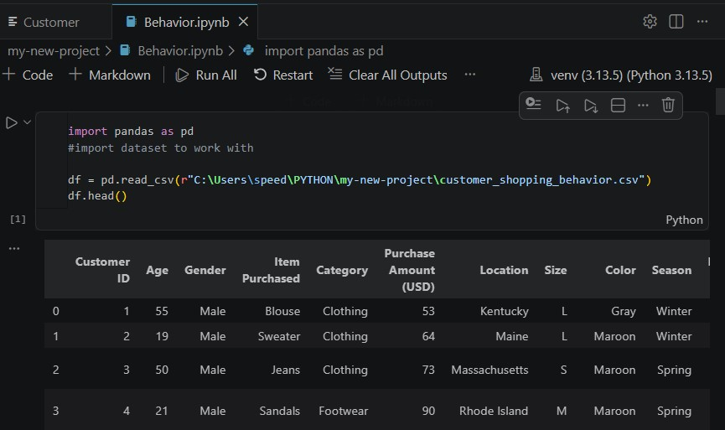

- Initial Exploration: Used df.info() to check structure and df.describ() for summary statistics
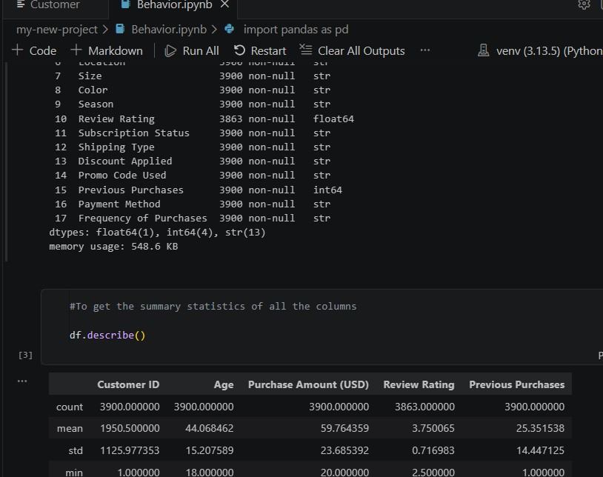
- Missing Value Handling: Checked for null values and imputed missing values in Review Rating column using the Median rating of each product category
- Column Standardization: Renamed columns to Snake case for easy readability and documentation
- Future Engineering:
  - Created age_group column by binning customer ages.
  - Created frequency_of_purchases_days from purchase days.
- Database Integration: Connected Python script to MSSQL and loaded the cleaned DataFrame into the database for SQL analysis.
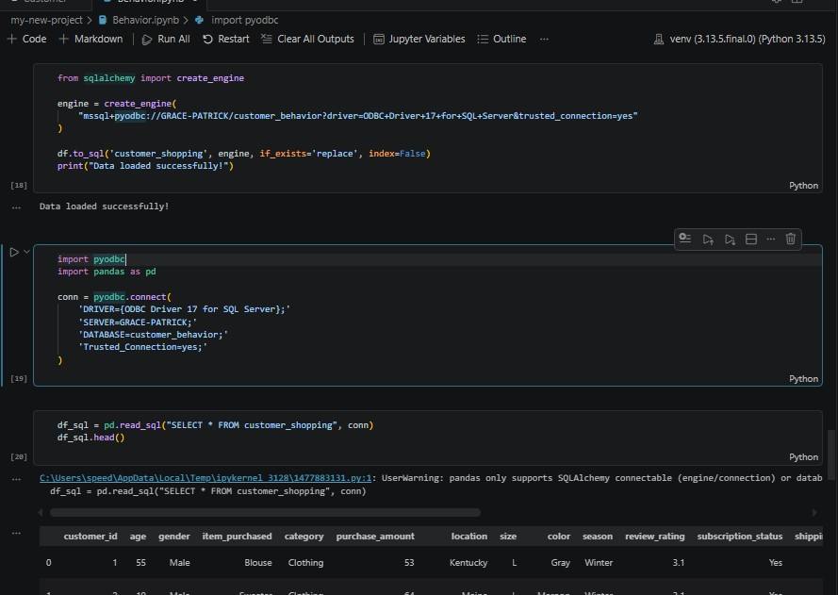

- Data Analysis using SQL
I performed structured analysis in MSSQL to answer key business questions:
- Revenue by gender
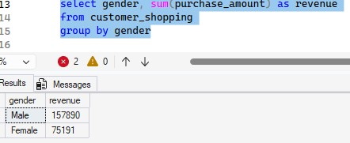
- High-Spending discount users
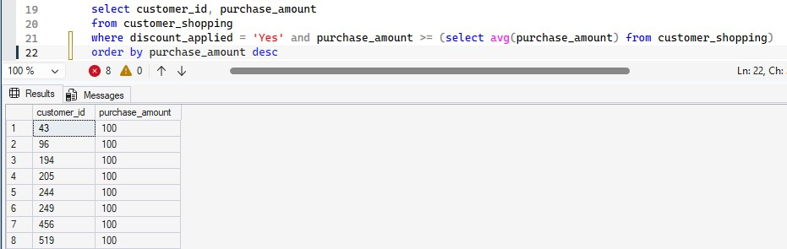

- Top 5 products by rating
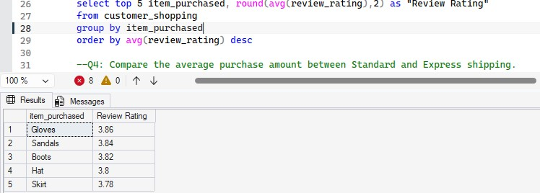

- Shipping types comparison
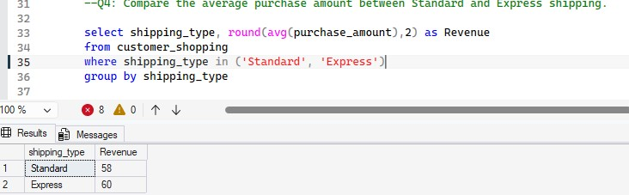
- Subscribers vs. non-subscribers
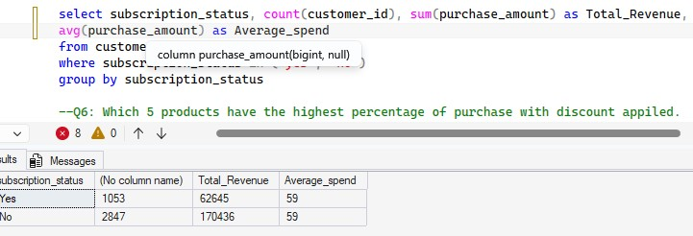

- Discount-dependent products
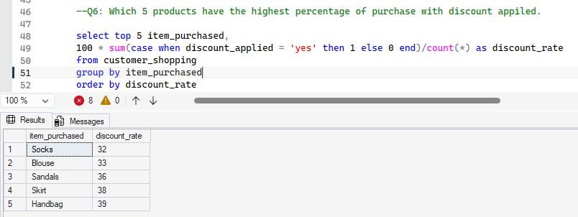

- Customer segmentation
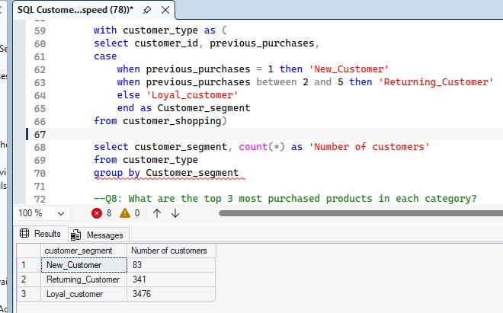

- Top 3 products per category
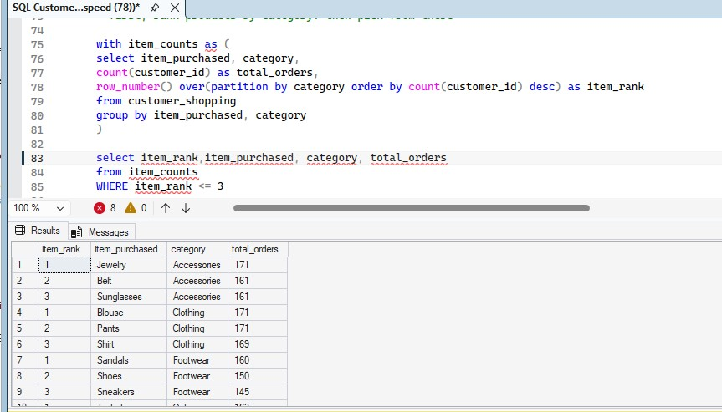

- Repeat buyers & Subscription status
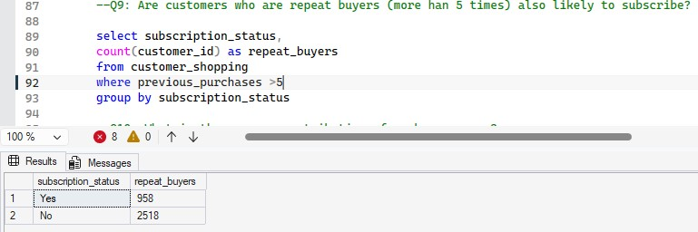

- Revenue by age group
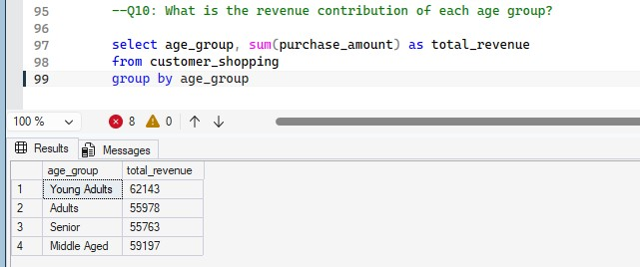

- Dashboard in Power BI
Finally, I built an interactive dashboard in Power BI to present visual insight to my analysis.
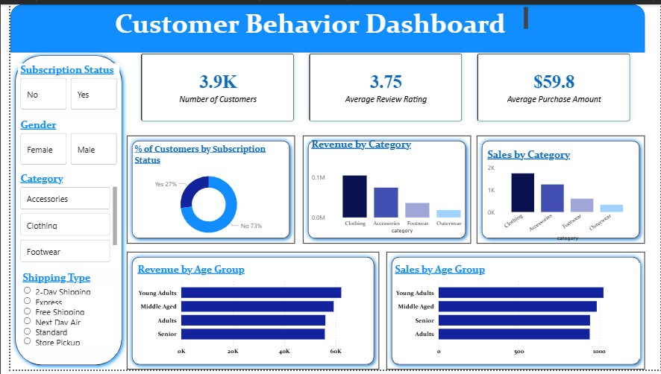
- Business Recommendation
- Booster Subscriptions – Promote exclusive benefits for subscribers.
- Customer Loyalty Programs – Reward repeat buyers to move them into Loyal customers.
- Review Discount Policy – Balance sales boosts with margin control.
- Product Positioning – Highlight top-rate and bestselling products in campaigns.
- Targeted Marketing – Focus efforts on high-revenue age groups and express-shipping.

